# Analysis Modelling

Structured Systems Analysis & Design Method (SSADM) is a hefty set of structured analysis and structured design techniques and graphical tools for identifying and transforming business requirements into software design specifications. For this portion, our group will be making use of the Data Flow Diagram (DFD) to process mapping of system.

DFD is a behaviour diagram which shows (from the process perspective) inputs, outputs, and data storage. It does not indicate timing between design objects inside a process, nor sequence of distinct processes. Fig 7 below shows our DFD.

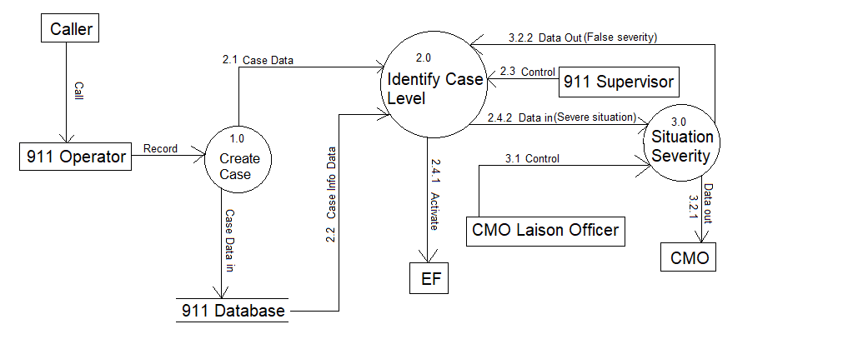

Fig 7: Data Flow Diagram

Referring to the data diagram, the caller first calls 911 operator which the operator create the data of incident report to the our create case process. In this process, the 911 operator creates a case based on this information, this data is passed into our 911 Database and at the same time it would pass to Identify Case Level process. Once Identify Case Level received the case, it will notify the 911 supervisor in-charge of classifying the case.

Upon classifying the case, firstly if the case is monkey (false incident), it would be pass back to the operator. Else if the case is Wolf or Tiger, the supervisor would activate (2.4.1) the EF. If the case determines to be a Demon, Dragon or God it would notify CMO Liaison officer via Situation Severity process through Data in (2.4.2). If CMO Liaison officer determines if the situation is true, the Data would be pass to CMO on Data out (3.2.1). Else if the situation determine to be non-severe, the data would be returned to 911 supervisor on data out(3.2.2) and it would then activate EF via Identify Case level Process.